Provincial Grand Chapter of Somerset

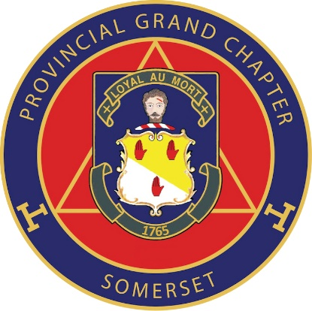

MEGS INSTALLATION & ANNUAL CONVOCATION

THURSDAY 19th MAY 2022 - DINING RETURN

I would like to dine at the Annual Convocation to be held at the

Webbington Hotel & Spa, Loxton, Nr Axbridge, Somerset. BS26 2HU

Name: -…………………………………………………………Rank: -……………………

Address: -……………………………………………………………………………………

………………………………………………………………….. Post Code: -……………..

Please seat me with: -……………………………………………………………………….

MENU

Tomato and mozzarella salad.
****
Chicken en croute
Or
Spinach and ricotta cannelloni (V)
****
Tea or Coffee & Mints

Cost £ 21.00 (wine NOT included)

Please specify any special dietary requirements: -…………………………………….

I enclose a cheque for £…………………made payable to The Provincial Grand Chapter of Somerset.
OR
Pay by BACS to Somerset Provincial Grand Chapter, sort code 30 91 20 account no. 00091518 AND send a confirming email to scribe@somersetroyalarch.org

Please return to: - Tony Beaumont ‘Melita’, Bishopswood, Chard. TA20 3RS.

BY SUNDAY 1st MAY AT THE LATEST

